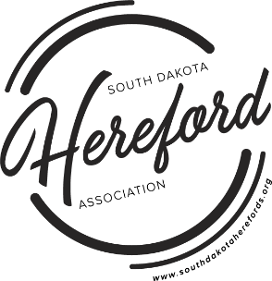**Contact:**

Taryn Reed

36951 229th St.

Wessington Springs, SD 57382

South Dakota Hereford Association

641-430-7787

[manager@southdakotaherefords.org](mailto:manager@southdakotaherefords.org)

November 4, 2024

Dear Members,

The South Dakota Hereford Association is calling for consignments for the 2025 Watertown Winter Farm Show and Sale! Registration is now open. The Hereford Show and Sale date will be Wednesday, February 12, 2025, which is the first day of the Watertown Winter Farm Show.

The Watertown Area Chamber Ag Committee has obtained sponsorships for the wood chips this year, so there will not be a sale expense for wood chips this year. The sponsors for the wood chips are: Eastside Equipment, Glacial lakes Veterinary Clinic, Pioneer, and Westside Implement. The Watertown Area Chamber Ag Committee has also obtained sponsorships for the video auction, so there will not be a sale expense for the video auction either. The video auction sponsors are: BZ Welding, Farmers Implement & Irrigation, Robertson Crop Insurance, and Spot On Printing. Please thank any of these sponsors when you have the opportunity.

**2025 WATERTOWN WINTER FARM SHOW DETAILS**

Hereford Show and Sale: Wednesday, February 12, 2025

**REGISTRATION**

To register, visit <http://sd-hereford.fairentry.com>

A registration “How To” instructions can be found at [www.southdakotaherefords.org](http://www.southdakotaherefords.org)

Entry Deadline: Saturday, November 16, 2024

Fees: Heifer and Bulls $100/head

Bred heifers that have calved after January 1, 2025 will be allowed to be shown.

Each consignor is limited to three bulls, at this time.

Any unused heifer grants may be used at this sale.

***2025 SDHA membership dues must paid and consignors must have also participated in 2024 Dakotafest foodstand, or pay a $200 non-participation fee.***

**PHOTOGRAPHS**

You will be able to submit a picture at time of registration that will be placed with the pedigree in the catalog. Cost will be $50 per picture and will be paid to the SDHA at time of registration through FairEntry (see link above).

**SALE COMMITTEE:**

Jeff Klages: 605-880-0521

Ryan Ollerich: 605-759-6405

Matt Zens: 605-310-5782